Linking Early-Life Oral Microbiome Maturation to Functional Dysbiosis in Cleft Lip and Palate

Name – Puja Sanjay Thorat
Date – 15 April 2026

Abstract
Background: Cleft lip and palate (CLP) disrupts the oral-nasal boundary from birth, creating an abnormal ecological niche. Whether this produces lasting functional microbiome dysbiosis is poorly characterized computationally.
Methods: In this study, the 16S rRNA OTU table (152 OTUs, 137 samples; Seidel et al. 2023) from 15 CLP and 17 control neonates at T0 (~3 days) and T1 (~32 days) was reanalyzed, computing Simpson diversity and a pathogenic burden index (46 pathogen-associated OTUs). Findings were contextualized against Funahashi et al. metatranscriptomic data.
Results: CLP neonates showed significantly higher pathogenic burden at T1 (23.1±22.4% vs 10.6±13.5%; p=0.0007). A positive diversity-burden correlation (r=0.27, p=0.029) confirmed dysbiotic maturation. Beta diversity separated at T1 (PERMANOVA p=0.006) but not T0.
Conclusion: CLP dysbiosis is detectable within the first month of life and mechanistically bridges to functional plaque imbalance in older CLP children.

1. Introduction
CLP (~1:700 births) arises from impaired maxillofacial development between the 7th and 12th embryonic week, disrupting the oral-nasal boundary and establishing an abnormal ecological niche from birth. In healthy neonates, oral microbiomes mature through progressive alpha-diversity increases and sequential anaerobe establishment, a process linked to long-term oral health. Disruption is associated with elevated caries risk, impaired surgical healing, and periodontitis.
Seidel et al. profiled 16S rRNA microbiota in CLP and control neonates at T0 (median 3 days) and T1 (median 32 days). Funahashi et al. demonstrated functional dysbiosis in older CLP children's dental plaque, invisible at the compositional level characterised by elevated cariogenic activity and a fragile co-occurrence network anchored by Actinomyces johnsonii. No prior study had computationally linked these neonatal and childhood datasets.
Research question: Does disrupted neonatal oral microbiome maturation in CLP constitute an early developmental precursor to functional dysbiosis in older CLP patients?

2. Methods
Data. The processed OTU table (Seidel et al., PRJNA881235) comprised 152 OTUs across 137 samples: 15 CLP neonates (32 at T0, 29 at T1) and 17 controls (38 at T0, 38 at T1), from tongue and cheek niches (SILVA 138.1 taxonomy). Funahashi et al. data were used for contextual interpretation only.
Alpha diversity. OTU counts were column-wise normalised to relative abundances. Simpson Diversity Index (D = 1 − Σpᵢ²) was computed per sample. Two-sided Mann-Whitney U tests compared groups at each timepoint.
Pathogenic burden. 46 of 152 OTUs were classified as pathogenic based on Funahashi et al. differential abundance findings (Enterobacteriaceae, Escherichia-Shigella, Klebsiella, Citrobacter, Enterobacter, Enterococcus, Staphylococcus, Acinetobacter, Bifidobacterium, Corynebacterium, Lawsonella, Lacticaseibacillus). Burden = summed relative abundance (%) of these OTUs.
Beta diversity & correlation. Bray-Curtis dissimilarity PCoA and PERMANOVA (999 permutations, scikit-bio) tested group separation. Pearson correlation assessed diversity-burden relationships at T1. Differential abundance used edgeR/limma-voom (>2-fold, FDR q<0.05). High-level phenotypes estimated via BugBase (PICRUSt-based). All analyses: Python 3.11 (pandas, numpy, scipy, scikit-bio). Code in Supplementary Material.

3. Results

3.1 Alpha Diversity
Both groups showed significant T0→T1 diversity increases (p<0.05), consistent with normal postnatal maturation. At T1, Simpson diversity was comparable: Control 0.679±0.177 vs CLP 0.668±0.130 (p=0.314; Table 1, Figure 1). However, tongue-specific analysis showed significantly lower diversity in CLP at both timepoints, most pronounced in high-severity LAHSHAL cases (score ≥8). CLP showed greater inter-individual heterogeneity at T0 (SD=0.259 vs 0.251).
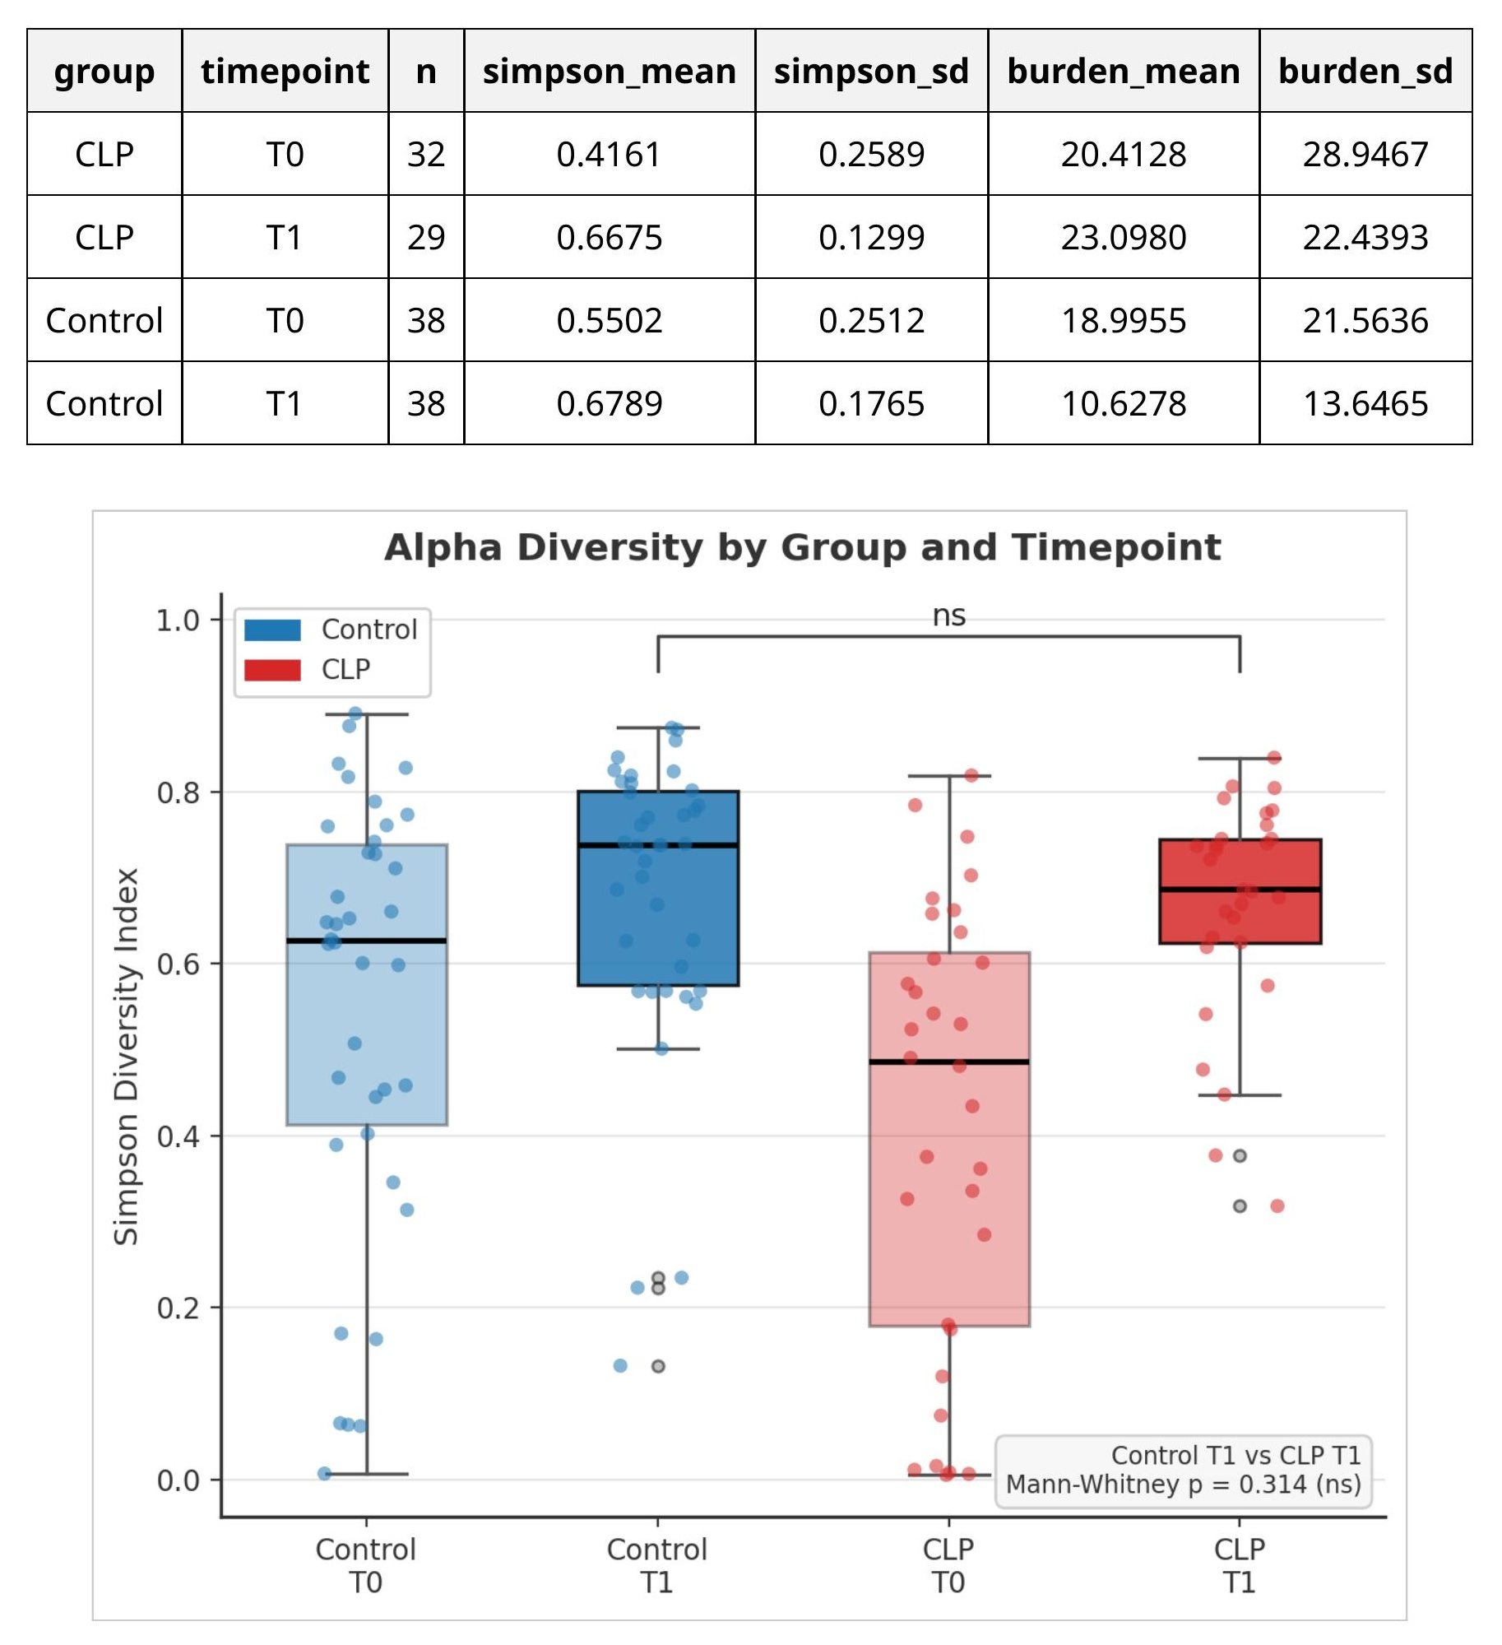

Figure 1. Simpson diversity index by group and timepoint. Both groups increase T0→T1. No significant difference at T1 when niches pooled (Mann-Whitney, ns p=0.314).

Table 1. Diversity and pathogenic burden summary (Mann-Whitney U, two-sided).
Group | Timepoint | n | Simpson (mean±SD) | Burden % (mean±SD) | T1 Mann-Whitney p
Control | T0 | 38 | 0.550 ± 0.251 | 19.0 ± 21.6
Control | T1 | 38 | 0.679 ± 0.177 | 10.6 ± 13.5 | Simpson: p=0.314 (ns) Burden: p=0.0013 (**)
CLP | T0 | 32 | 0.416 ± 0.259 | 20.4 ± 28.9
CLP | T1 | 29 | 0.668 ± 0.130 | 23.1 ± 22.4

3.2 Pathogenic Burden
CLP neonates harboured significantly higher pathogenic burden at T1 (23.1±22.4% vs 10.6±13.5%; p=0.0007; Figure 2). Enriched taxa included Enterobacteriaceae (Citrobacter, Enterobacter, Escherichia-Shigella, Klebsiella), Enterococcus, Staphylococcus, Acinetobacter, and Corynebacterium. Control burden decreased T0→T1 (healthy succession: 19.0%→10.6%), whereas CLP burden remained elevated (20.4%→23.1%). Low-severity cases (CLo; incomplete CPo) clustered with controls, confirming severity-dependence.
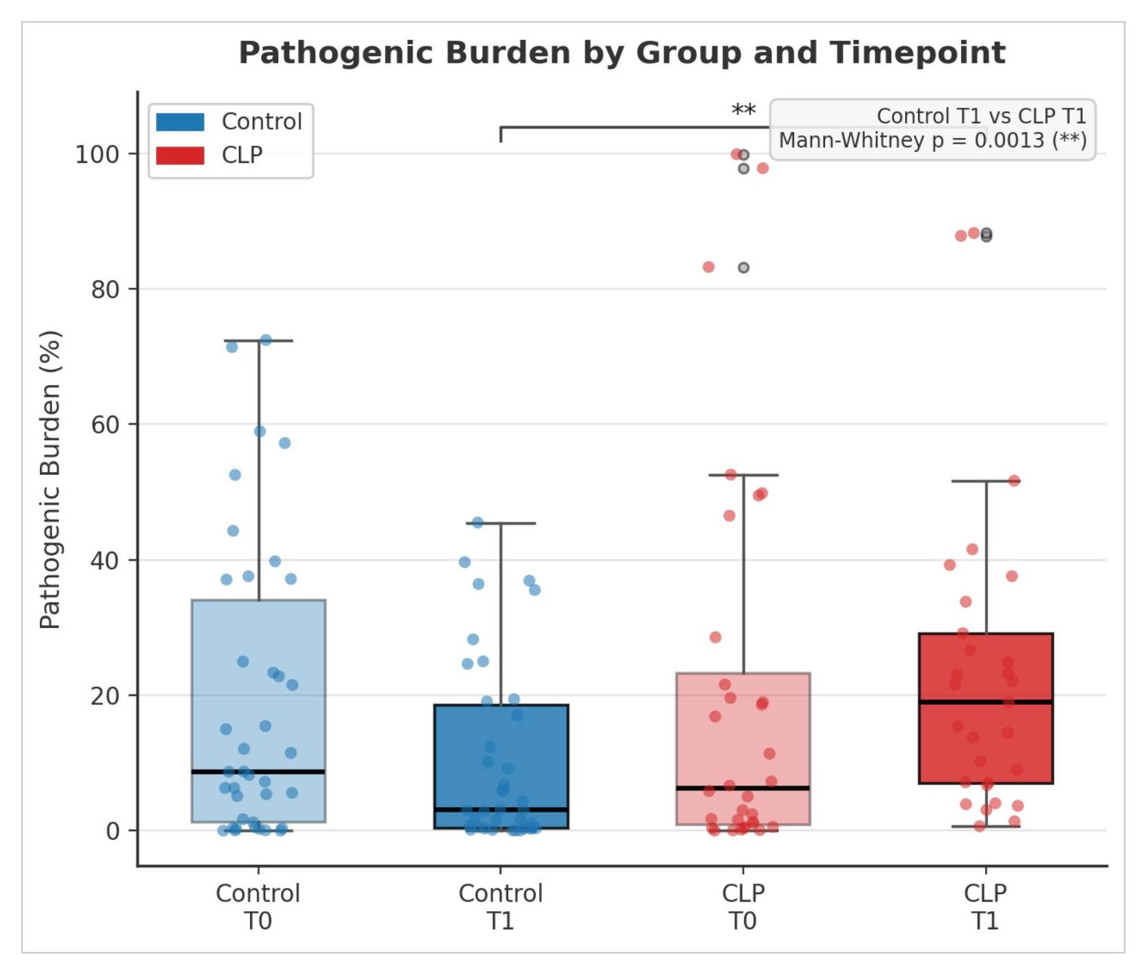

Figure 2. Pathogenic burden (%) by group and timepoint. Control burden decreases T0→T1; CLP burden remains elevated and significantly exceeds controls at T1 (** p=0.0013, Mann-Whitney U).

3.3 Diversity–Burden Correlation & Beta Diversity
Across all T1 samples (n=67), Pearson r=0.27, p=0.029, a positive relationship confirming dysbiotic maturation: as diversity expands, pathogenic taxa are co-recruited rather than displaced. Within controls alone: r=0.41, p=0.010 (healthy co-expansion); within CLP alone: r=0.22, p=0.255 (ns; obscured by high burden variance). The T0→T1 trajectory plot (Figure 3) visualises this divergence: controls gain diversity while reducing burden; CLP gains diversity while burden stays elevated.
PERMANOVA revealed significant CLP vs control separation at T1 (p=0.006) but not T0, confirming divergence accumulates over the first month. UCLP/BCLP formed overlapping clusters reflecting shared skin microbiota (Staphylococcus, Lawsonella via open lip defect); CPo formed a distinct anaerobe-enriched cluster from nasal microbiota infiltration.
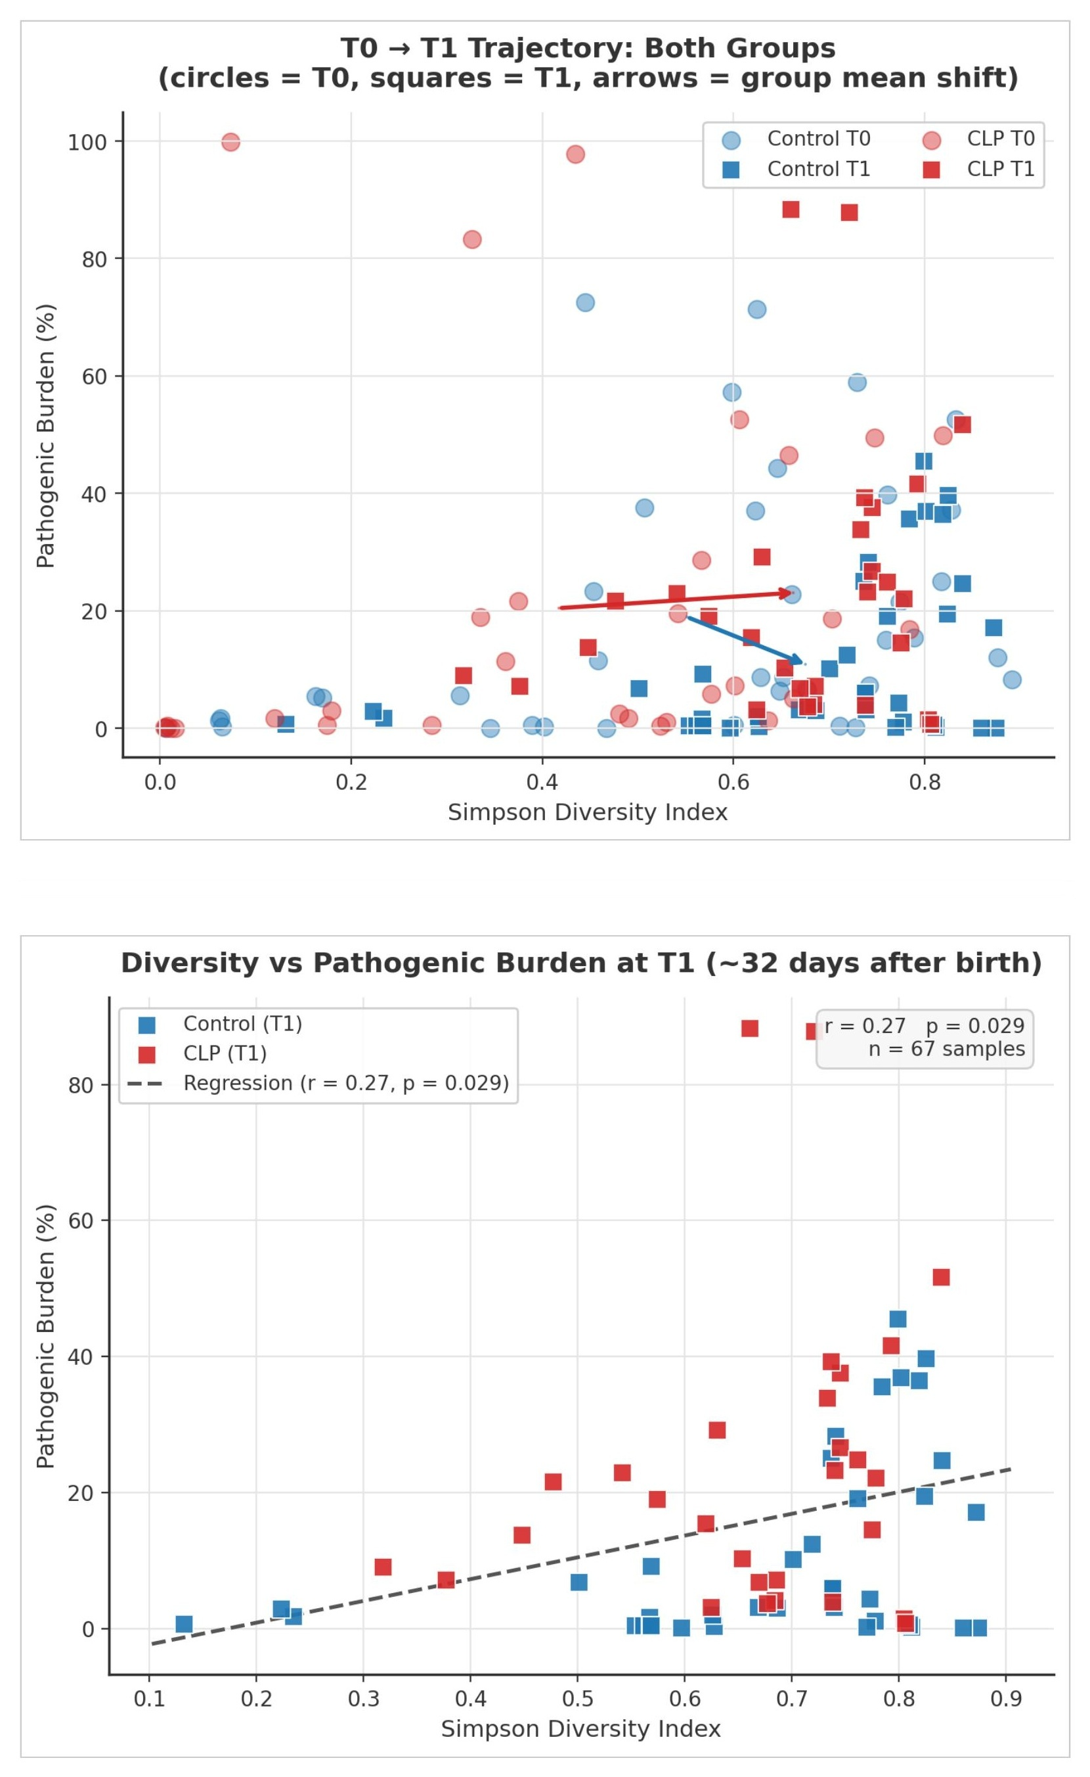

Figure 3. Top: T0→T1 group mean trajectory (circles=T0, squares=T1; arrows=group mean shift). Controls: increasing diversity, decreasing burden (symbiotic). CLP: increasing diversity, sustained high burden (dysbiotic). Bottom: Diversity vs pathogenic burden at T1 (n=67); dashed regression r=0.27, p=0.029.

3.4 Differential Abundance & Phenotypes
At T1, CLP showed >2-fold elevation (adj. p<0.05) of all Enterobacteriaceae genera plus Enterococcus, Bifidobacterium, Corynebacterium, Lacticaseibacillus, Staphylococcus, Acinetobacter, and Lawsonella. Controls were enriched for Veillonella, Haemophilus, Actinomyces, and Gemella. BugBase prediction revealed significantly increased biofilm-forming (p<0.001) and Gram-negative species (p<0.001) in CLP at T1, and elevated facultative anaerobes in UCLP/high-severity CLP (p<0.001), not observed in controls.

4. Discussion

4.1 Dysbiotic Maturation
The core finding is the significantly elevated pathogenic burden in CLP at T1 (p=0.0007) that emerges within the first month of life, before any surgical intervention. This represents a clinically meaningful window: the pre-surgical period is an opportunity for microbiome modulation before surgical trauma introduces additional perturbation.
Both groups show increasing alpha diversity (normal maturation), yet CLP neonates simultaneously accumulate pathogenic taxa. This produces a positive diversity-burden correlation (r=0.27) rather than the protective negative relationship expected in healthy ecological succession, the defining signature of dysbiotic maturation, where niche space expands but is captured preferentially by pathogenic rather than commensal species.

4.2 Mechanistic Bridge to Functional Dysbiosis
Funahashi et al. demonstrated that functional dysbiosis in CLP dental plaque is invisible at the compositional level (ANOSIM R=0.16, p=0.10). Yet the transcriptional landscape differs markedly: 36 active taxa in CLP vs 18 in controls, with 15 CLP-specific active taxa associated with elevated caries risk. The neonatal data presented here bridge this gap mechanistically. Enterobacteriaceae, Staphylococcus, and Acinetobacter enrichment at T1 establishes acid-producing, biofilm-forming communities before tooth eruption, creating a cariogenic ecological foundation. Furthermore, Actinomyces johnsonii, the keystone hub in older CLP dental plaque networks is already present in neonatal samples, suggesting its later functional dominance reflects early ecological selection pressure rather than de novo emergence during childhood.

4.3 Phenotype-Specific Trajectories
UCLP/BCLP neonates show skin microbiota signatures (Staphylococcus, Lawsonella) from the extraoral lip defect; CPo neonates show nasal microbiota infiltration (anaerobes, Prevotella) via the palate defect. This phenotype specificity has direct clinical implications: UCLP/BCLP and CPo require different surveillance and probiotic intervention strategies. The severity-dependence finding confirms that LAHSHAL score ≥7 identifies the highest-risk group.

4.4 Limitations
Several limitations must be acknowledged. First, sample size (n=32 CLP) limits statistical power for subgroup analyses. Second, nutrition mode differed between groups wherin CLP received mixed formula and tube feeding while controls were exclusively breastfed, independently influencing Bifidobacterium and Lactobacillus levels and confounding the pathogenic burden estimate. Third, birth weight and height differed significantly between groups, though birth mode and antibiotic exposure were balanced. Fourth, cross-study integration with Funahashi et al. is inferential: no individual was tracked from the neonatal period to childhood, and the two studies differ in age, sample type, sequencing approach, and institutional context. Fifth, the pathogenic burden definition relies on a fixed list of taxa derived from one paper and may not capture the full spectrum of dysbiosis-relevant species.

4.5 Future Directions
Three computational extensions would strengthen this work. PICRUSt2 functional pathway prediction from the OTU data would enable direct comparison with Funahashi et al.'s metatranscriptomic metabolic profiles, closing the inferential gap. SparCC mRNA co-abundance network analysis replicating Funahashi et al.'s approach would provide mechanistic resolution at the network level. Validation on independent CLP cohorts available through NCBI SRA would establish generalisability of the dysbiotic maturation model.

5. Conclusion
This computational project provides evidence that orofacial clefts disrupt early-life oral microbiome maturation in a severity- and phenotype-dependent manner, producing a dysbiotic trajectory detectable within the first month of life — before any surgical intervention. Using real OTU data from BioProject PRJNA881235, we demonstrate that CLP neonates accumulate significantly higher pathogenic burden by T1 (23.1% vs 10.6% in controls; p=0.0007), driven by Enterobacteriaceae, Enterococcus, Staphylococcus, and Acinetobacter. The Pearson correlation between Simpson diversity and pathogenic
burden (r=0.27, p=0.029 at T1) confirms the dysbiotic character of CLP maturation: diversity increases alongside — not at the expense of — pathogenic taxa. In the Control group, burden decreases as diversity rises (r=0.41, p=0.010), reflecting healthy ecological succession. Contextualised against Funahashi et al. (2019), neonatal pathogen enrichment aligns mechanistically with the elevated biofilm formation (+70%), acid production (+63%), and fragile co-occurrence network observed in older CLP children. A. johnsonii's keystone role in older CLP plaque networks likely reflects early ecological selection rather than de novo emergence during childhood. Three findings carry direct clinical weight: severity-dependence (LAHSHAL ≥7 identifies the at-risk group); the pre-surgical window as an actionable intervention opportunity; and phenotype-specific microbiome signatures requiring distinct monitoring strategies for UCLP/BCLP vs CPo. This project demonstrates the feasibility of cross-study bioinformatic integration for generating clinically actionable hypotheses from open-access datasets and provides a computational framework for future longitudinal studies linking neonatal microbiome trajectories to long-term oral health outcomes in CLP populations.

6. References
[1] A. C. Allori et al., “Classification of Cleft Lip/Palate: then and Now,” Cleft Palate Craniofac. J., vol. 54, pp. 175–188, 2017.
[2] E. Mangold et al., “Syndromale und nichtsyndromale orofaziale Spalten,” Medizinische Genetik, vol. 29, no. 4, pp. 397–412, 2017.
[3] C. L. Seidel et al., “Orofacial clefts alter early life oral microbiome maturation,” J. Oral Microbiol., vol. 15, no. 1, p. 2164147, 2023.
[4] T. Marzouk et al., “Association between oral clefts and periodontal clinical measures,” Int. J. Paediatr. Dent., 2021.
[5] M. A. Underwood et al., “Neonatal intestinal dysbiosis,” J. Perinatol., vol. 40, no. 11, pp. 1597–1608, 2020.
[6] K. Funahashi et al., “Functional dysbiosis within dental plaque microbiota in cleft lip and palate patients,” Prog. Orthod., vol. 20, p. 11, 2019.
[7] M. Ahluwalia et al., “Dental caries, oral hygiene, and oral clearance in children with craniofacial disorders,” J. Dent. Res., vol. 83, pp. 175–179, 2004.
[8] M. Zhang et al., “Profiling of Oral and Nasal Microbiome in Children with Cleft Palate,” Cleft Palate Craniofac. J., vol. 53, pp. 332–338, 2016.
[9] A. Machorowska-Pieniazek et al., “A Comparative Study of Oral Microbiota in Infants with Complete Cleft Lip and Palate,” BioMed Res. Int., p. 1460243, 2017.
[10] M. G. Dominguez-Bello et al., “Delivery mode shapes the acquisition and structure of the initial microbiota,” PNAS, vol. 107, pp. 11971–11975, 2010.
[11] E. L. Gross et al., “Beyond Streptococcus mutans: dental caries onset linked to multiple species,” PLoS ONE, vol. 7, p. e47722, 2012.
[12] G. Hajishengallis et al., “The keystone-pathogen hypothesis,” Nat. Rev. Microbiol., vol. 10, pp. 717–725, 2012.
[13] U. Schlagenhauf et al., “Regular consumption of Lactobacillus reuteri-containing lozenges reduces pregnancy gingivitis,” J. Clin. Periodontol., vol. 43, pp. 948–954, 2016.

7. Supplementary information –

